Project
KABILESHAR RAMAKRISHAN MOHAN KUMAR
2023/04/15

Table of Contents

Overview……….....................................................................................................................3
Preparation..........................................................................................................................3

Topology….……...................................….............................................................................4

Part1-Configuring Firewall..........................................................................................4

Part 2Enabling a VPN IPsec Tunnel between the two sites ……………………..10

Part3 Security policies……………………….…………………..............................................15

Part 4 Zoom Link……………………………….......................................................................18

INFO8501 – Site to Site VPN
Introduction:
The objective of this project is to design and implement a site-to-site Virtual Private Network (VPN) solution based on a set of policy requirements. The project involves creating a topology and implementing the necessary configurations in Palo Alto Firewall.
Overview
This project aims to create a site-to-site VPN solution to achieve specific policy requirements. The policies include providing access to servers and the Internet for all staff members at the headquarters site. Guests at the headquarters site should have access to the Internet only, and all hosts at the headquarters site must access the Internet from the headquarters site.
For this project, I need to create a secure network that connects the main office and the branch office. All employees at both offices should have access to the servers at the main office through a secure VPN connection over the internet. Additionally, employees at the branch office should be able to access the internet through their own network, but guests should only have access to the internet and not to the office network. All internet access needs to go through NAT, and no unauthorized access should be allowed.
Preparation
- Cisco Switches
- Cisco Routers
- 5 VM
- Palo Alto Firewall
- PC
- Putty
TOPOLOGY
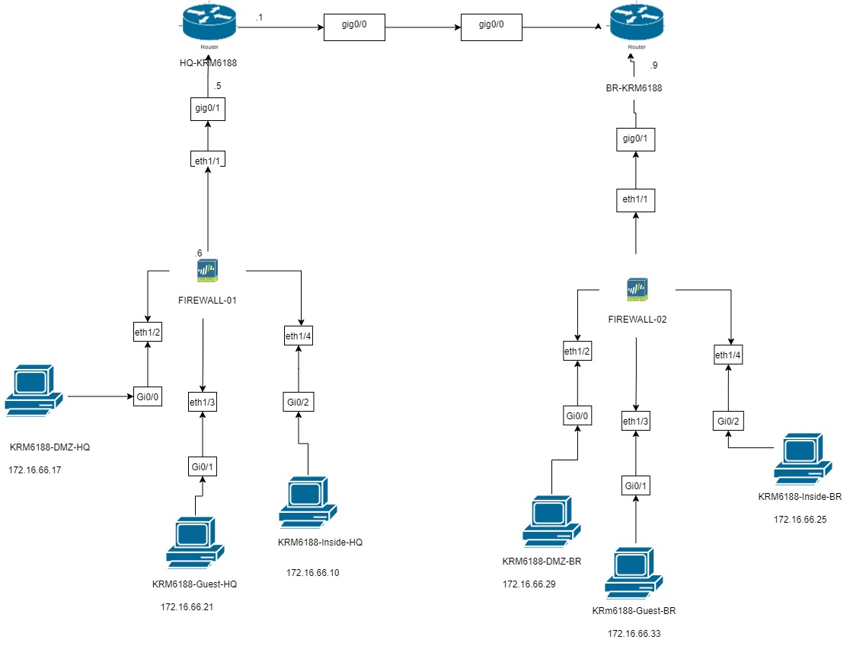
Part one : Configuring Firewall
Overview
This setup involves assigning interfaces to the network topology, adding the virtual routers to enable routing, creating network zones, connecting VMs to test the connectivity of the firewall, and configuring network address translation.

Observations
- For Both the firewall assigned the interface to a specific network Zones such as:
•Ethernet1/1 - Internet (172.16.66.6/30) & (172.16.66.10/30)
• Ethernet1/2 - Inside (172.16.66.13/30) & (172.16.66.25/30)
• Ethernet1/3 - DMZ (172.16.66.17/30) & (172.16.66.29/30)
• Ethernet1/4 - GUEST (172.16.66.21/30) & (172.16.66.33/30)

- Configured layer 3 interfaces with the assigned interface settings in the firewall GUI web page.Also Configured the Ethernet1/1, Ethernet1/2, Ethernet 1/3, Ethernet1/4 interface as Internet, Layer 3, with a static IP address.
- Added a virtual router to enable routing between the different networks created. This involves also renaming the router to KRM6188-VR , adding all the interfaces assigned in Step 2, and also added a static route for the firewall default gateway.
- Created network zones for both the firewall such as Internet, Inside , DMZ, Guest and added each interfaces to its respective Zones.
- Connected the VM’s to check the connectivity of the firewall. This involves configuring the IP address on the second interface of VM01, pinging the firewall from VM01 (which also will be blocked due to the firewall settings), created a management profile for the interface to allow ping, and committing the changes to the firewall.
- Configured the network address translation (NAT) to translate the private network in the Inside and DMZ zones to a routable address on the Internet. This is done by creating a Source NAT policy and also configuring the original and translated packets.

Screenshots
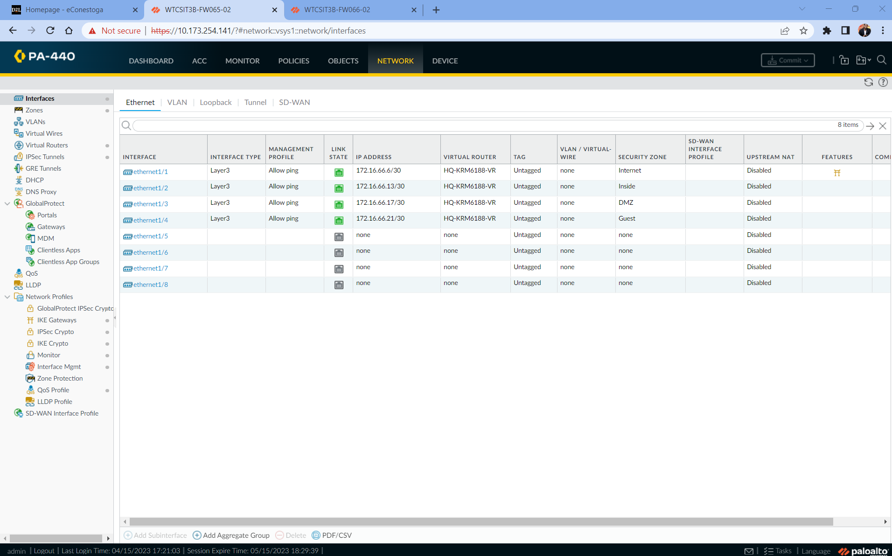Fig 1.1 Palo alto firewall 1 network interface is configured

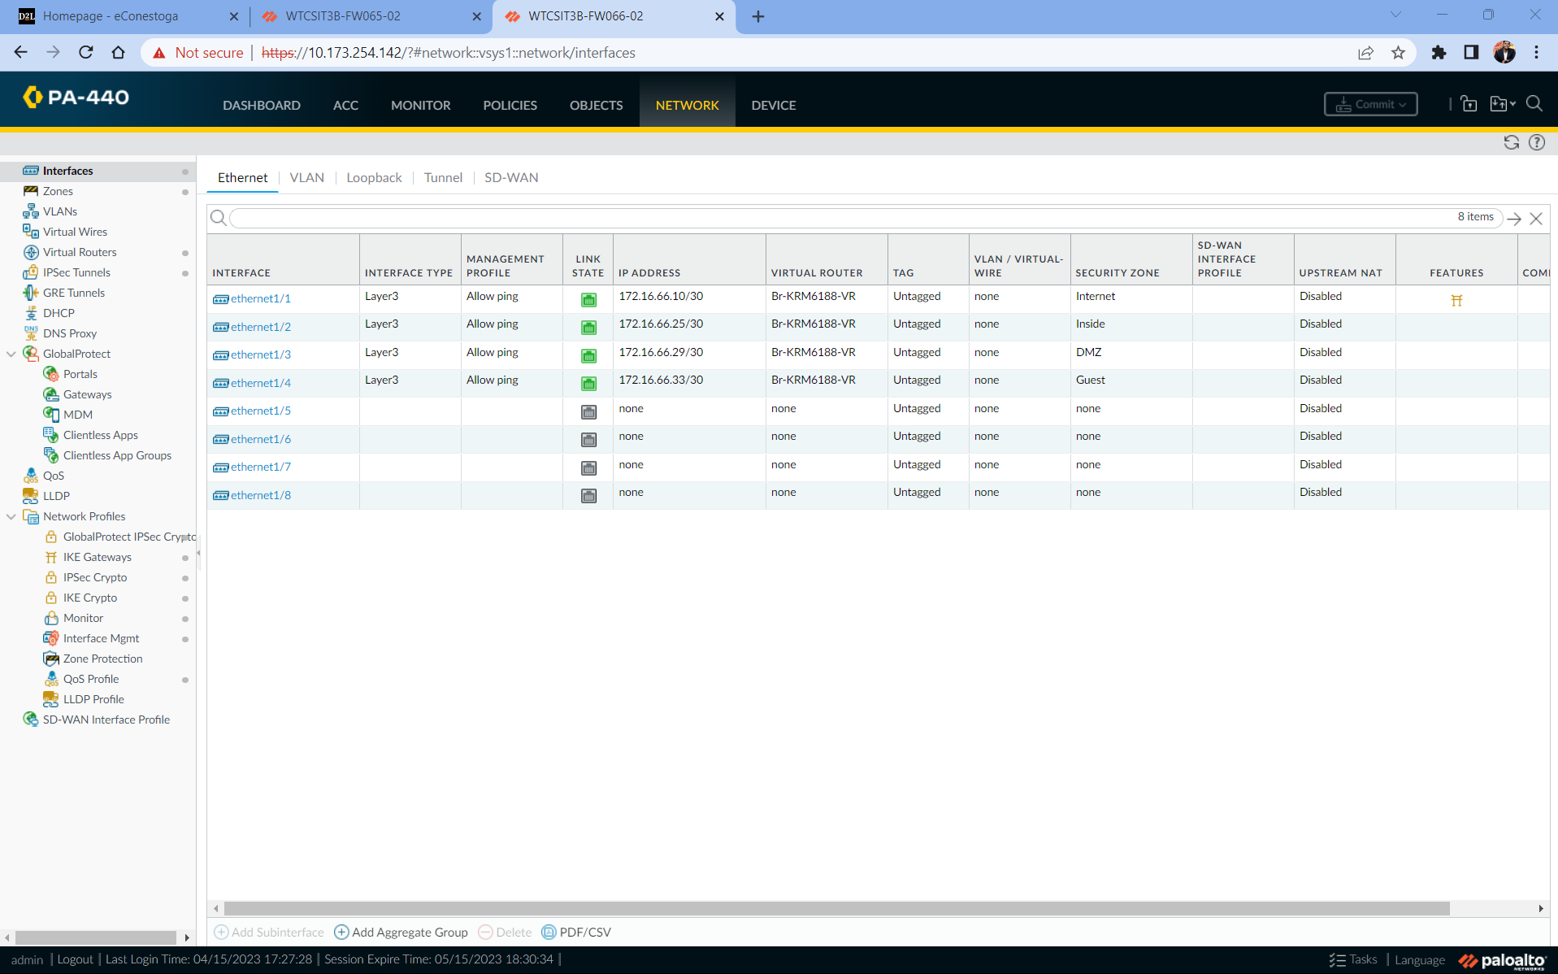
Fig 1.2 Palo alto firewall 2 network interface is configured
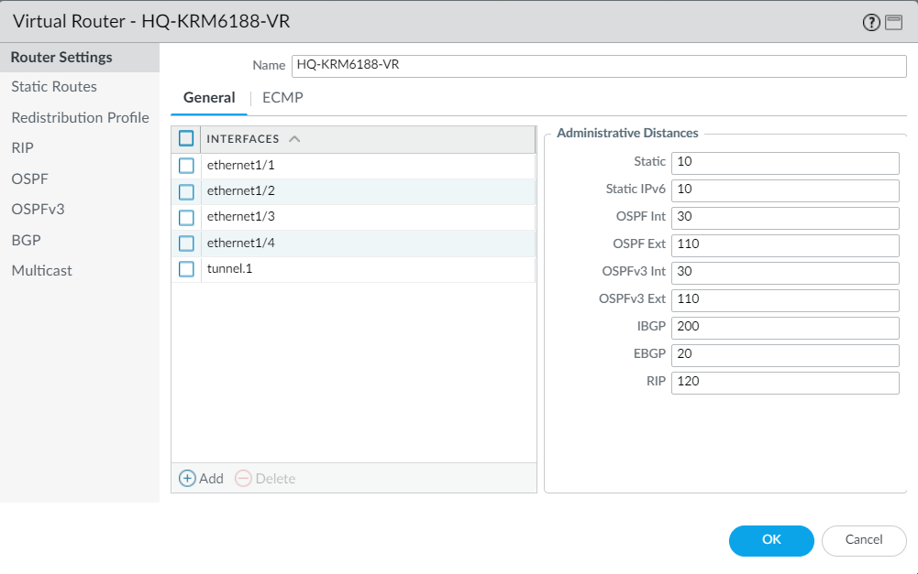
Fig 1.3 Virtual Router with static routes is configured for HQ-KRM6188-VR
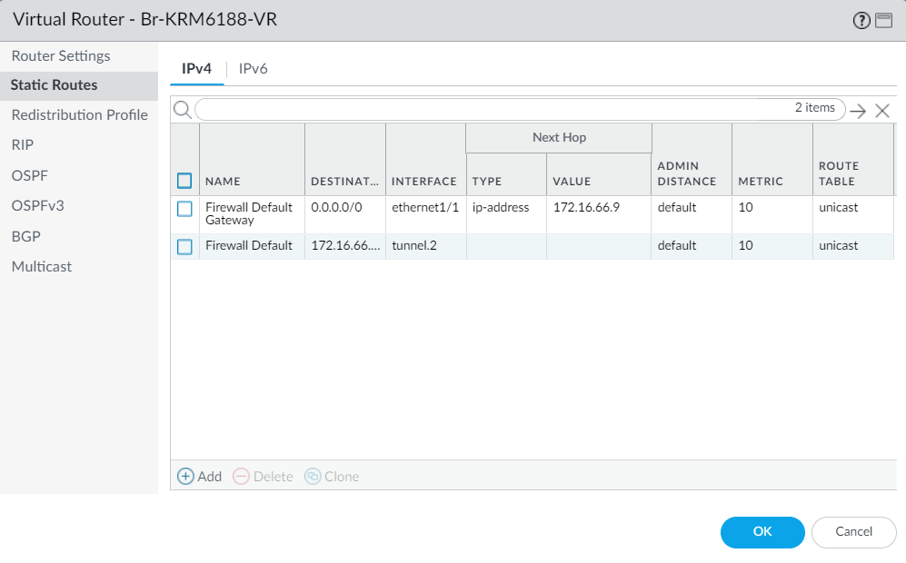
Fig 1.4 Virtual Router with static routes for Br-KRM6188-VR
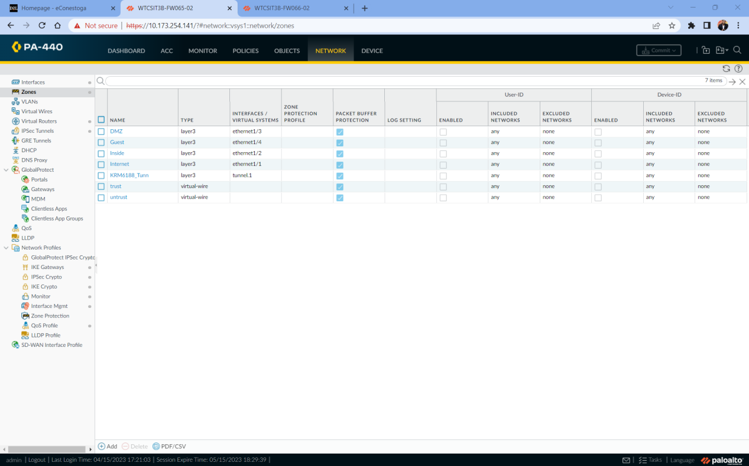
Fig 1.5 Zones for interfaces is configured and assigned (HQ)
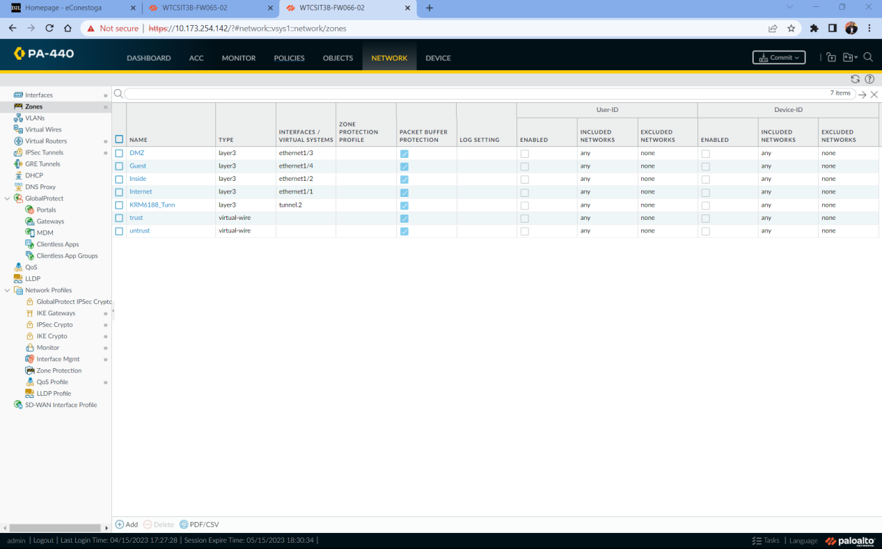
Fig 1.6 Zones for interfaces is configured and assigned (BR)

Fig 1.7 Management Profile is set for HQ

Fig 1.8 Management Profile is set for BR

Reflection
Through this part of the project I was able to learn how to configure steps taken to configure the firewalls and set up the network zones, interfaces, and virtual router . By assigning each interface to a specific network zone and configuring layer 3 interfaces with static IP addresses, the network topology is well defined and can easily accommodate changes or additions in the future. Additionally, to enable the routing between networks I configured the virtual router which ensures that traffic can flow between the zones while maintaining security.

Part Two : Enabling a VPN IPsec Tunnel between the two sites
Overview
In this part I am setting up a secure connection between two locations using a Virtual Private Network (VPN) with IPSec encryption. This will allow the two locations to communicate with each other over the internet in a secure manner.
Observation
- Validated the Ip connectivity between the networks . Configured the routing for both the networks using the following command in Putty (connecting the devices)
interfaces
Ip add
ip route 0.0.0.0 0.0.0.0 (ip)
- Created a tunnel interface and attached it to a virtual router and the security zone.Created a new tunnel interface with a HQ-KRM6188 & BR-KRM6188 and attach it to a virtual router and a security zone. Also noted that the IP address is not required for the tunnel interface.
- Configured a static route on the virtual router to the destination subnet.Added a static route to the destination subnet on the virtual router for the VPN tunnel. Also did a static routing for the subnets in the putty
- Configured the crypto profiles such as IKE Crypto profile for phase 1 and IPSec Crypto profile for phase 2. Created new profiles for IKE Crypto and IPSec Crypto. These profiles will be used to configure the encryption and authentication settings for the VPN tunnel.
- Configured the IKE Gateway by created a new IKE Gateway object and configure its settings. Also specified the name, version, interface, local and peer IP addresses, pre-shared key, and authentication type.
- Configured the IPSec Tunnel. Created a new IPSec Tunnel object and configure its settings. Also specified the name, tunnel interface, address type, IKE Gateway, and IPSec Crypto profile.
- Tested the site to site vpn using the following :
Initiate IKE Phase 1
1. test vpn ike-sa gateway <gateway_name>
2. show vpn ike-sa gateway <gateway_name>
Initiate IKE Phase 2
1. test vpn ipsec-sa tunnel <tunnel_name>
2. show vpn ipsec-sa tunnel <tunnel_name>
- Tunneling for two sites is configured successfully
Screenshots
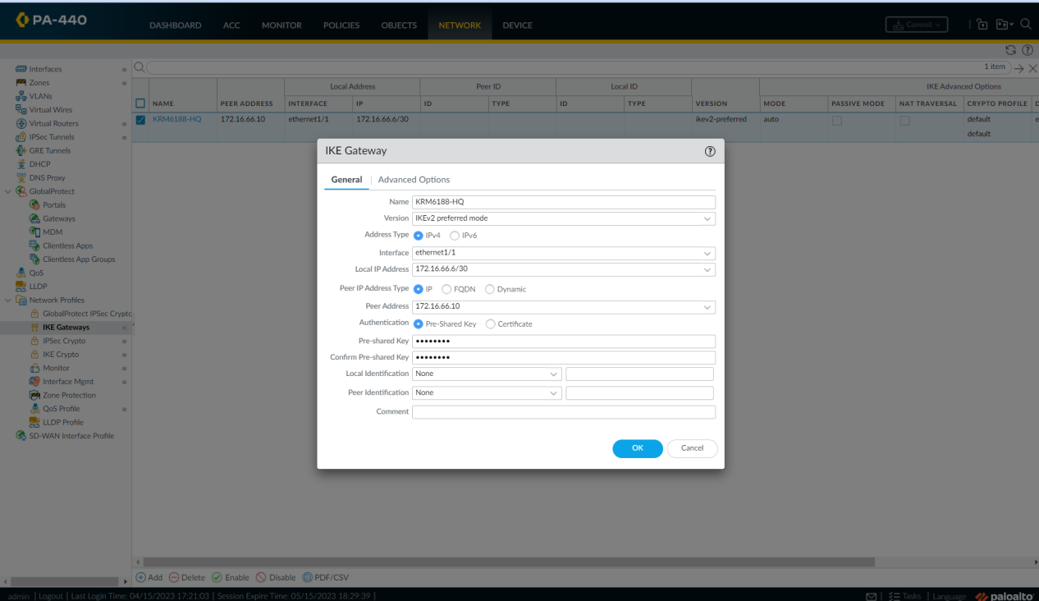
Fig 2.1 IKE Gateway for HQ is configured with proper name and version
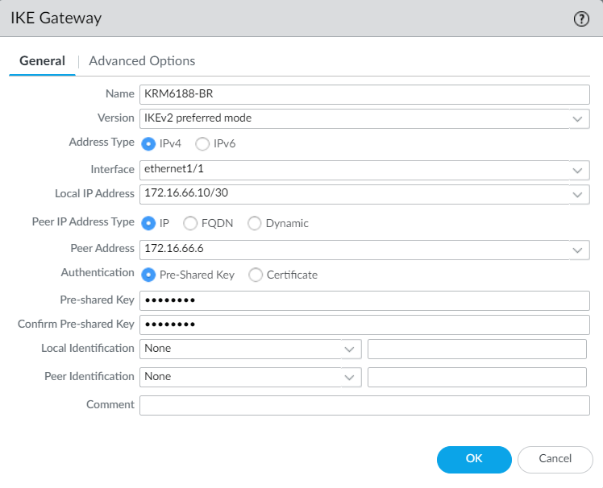
Fig 2.2 IKE Gateway for BR is configured with proper name and version
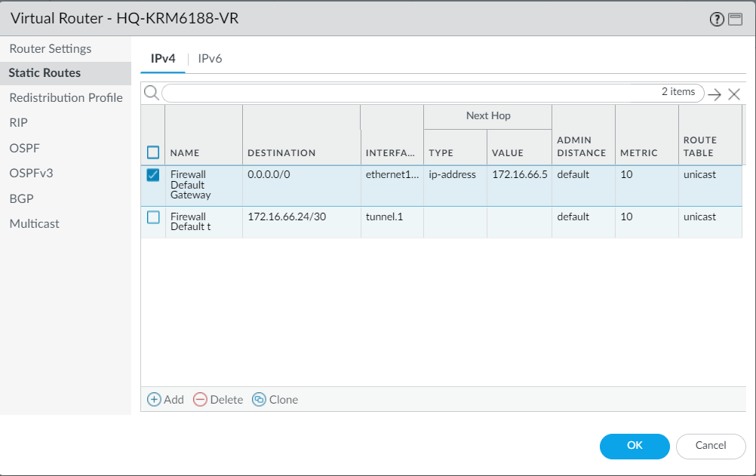
Fig 2.3 Static routes is configured for HQ

Fig 2.4 Static Routes for BR
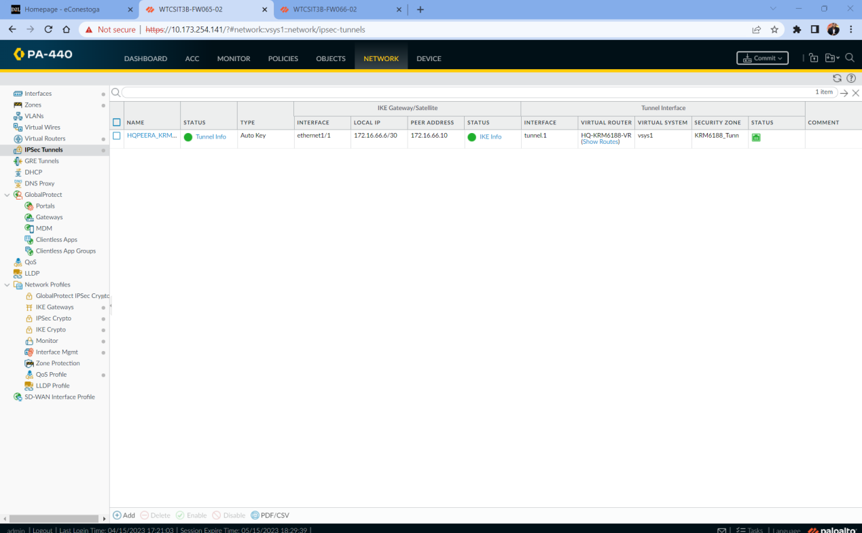
Fig 2.5 Tunneling is configured successfully for HQ
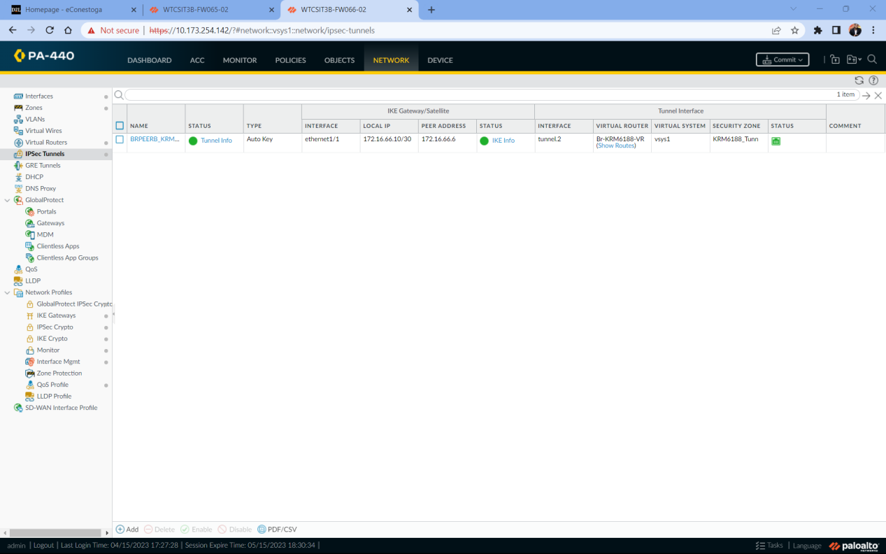
Fig 2.6 Tunneling for BR is successfully configured
Reflection
Through this part of the lab I was able to learn that Creating a secure connection between two networks is important, especially if the data transmitted over the internet contains sensitive information. One way to secure the communication is by establishing a VPN IPsec tunnel between two locations. This process involves setting up encryption and authentication methods that ensure data is protected against unauthorized access. It's essential to use reliable authentication methods and powerful encryption algorithms, such as AES, to guarantee the security of the VPN IPsec connection. Thorough design, configuration, and testing of the link are necessary to ensure it is secure and working correctly. In summary, establishing an IPsec VPN tunnel is a vital step in securing online communication.

Part three : Creating security policy for the sites
Overview
In this part of the lab Security policy will be created in both of the networks. Through this connectivity of the sites is ensured

Observations
- Security policies are created such as Inside to DMZ , Inside to internet, DmZ to internet , BR to HQ , Guest to Internet. This is done for the HQ
- Security policies are created such as BR to HQ , Guest to Internet, Inside to Internet. This is done for the BR
- Successfully pinged from Guest to Internet
- Successfully pinged from BR to HQ
- Successfully pinged from Inside to Internet
Screenshots
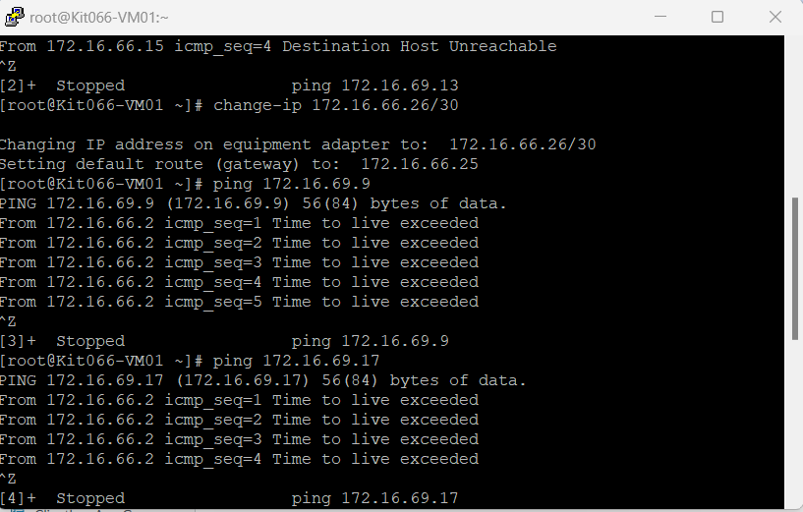
Fig 3.1 Pinged from Branch inside

Fig 3.2 Ping from Inside to Internet

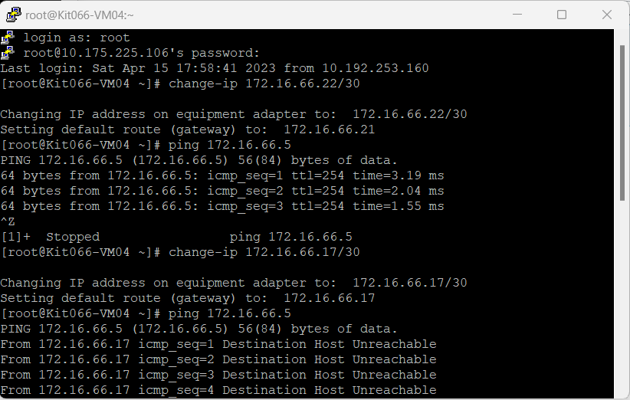
FIg 3.3 Ping from HQ DMZ to HQ Internet
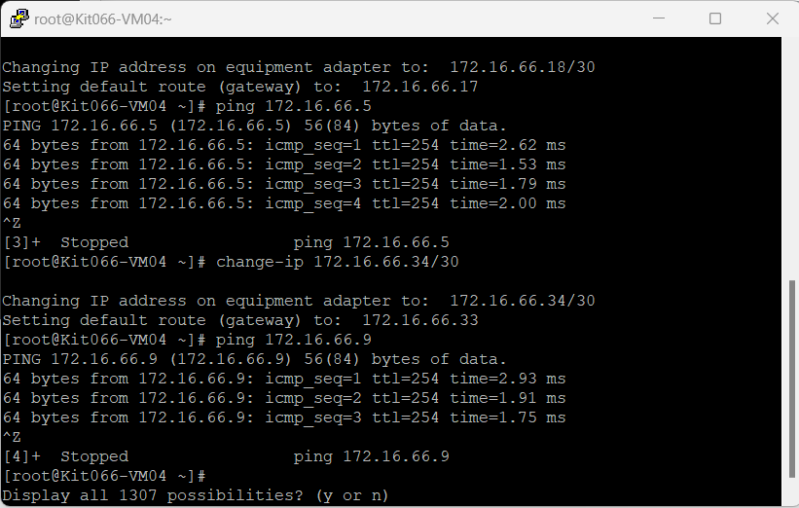
Fig 3.4 Ping to Branch Guest
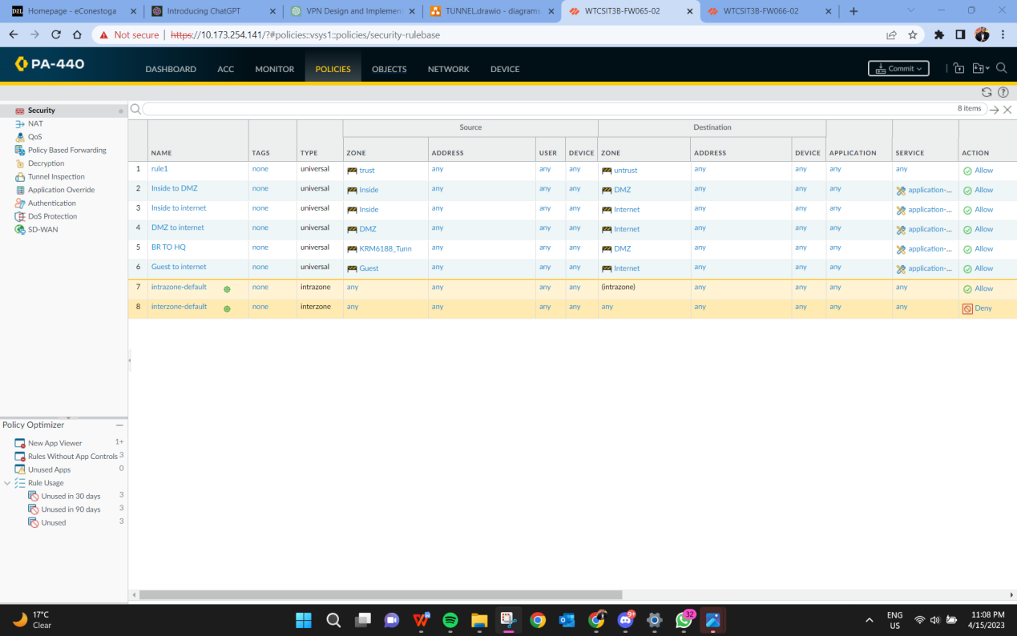
Fig 3.5 Security policy of HQ
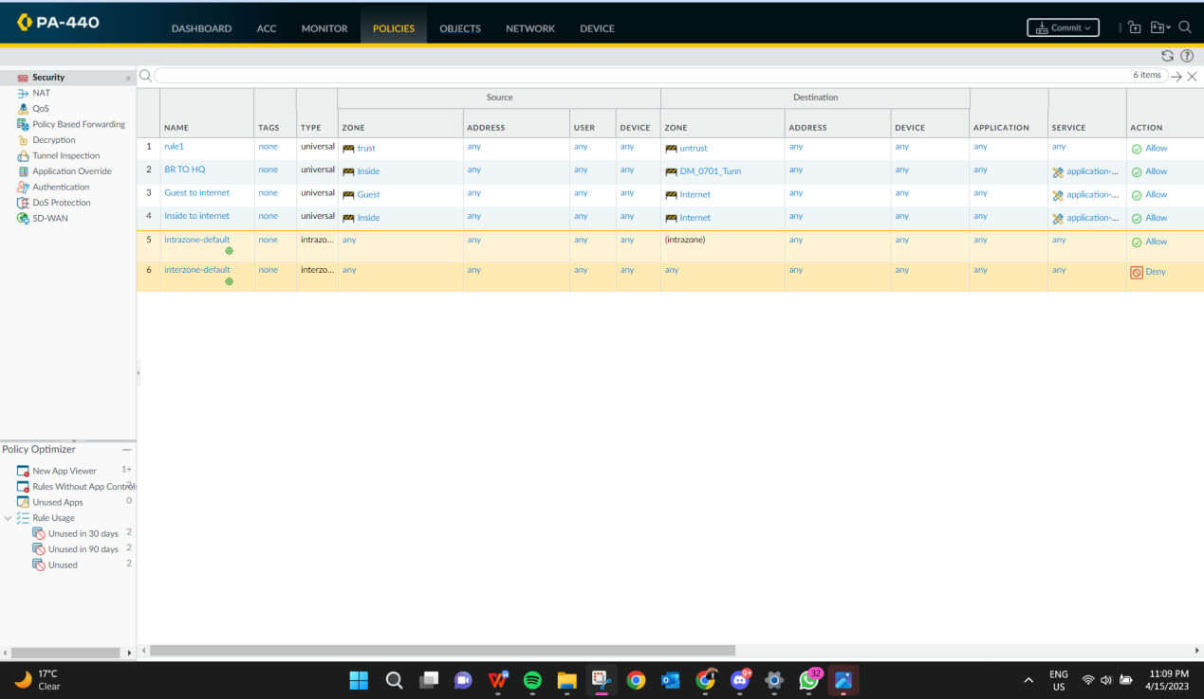
Fig 3.6 Security policy of BR

Reflection
From this part of the lab I came to know that it's important to have a clear security policy in place for the sites involved. This policy should outline the steps I’ll take to protect the data and communication between the sites from outside threats. This includes setting up secure VPN IPsec tunnels between the sites to encrypt the data being transmitted, and configuring firewalls and VPN devices to ensure only authorized access is allowed. I used reliable authentication methods and encryption algorithms to ensure the security of the connection. It's essential to thoroughly design, configure, and test the VPN IPsec tunnel to ensure it's working correctly and securely. Overall, the security policy is crucial for ensuring the safety of our project's data and communication

